Steps to setup ElasticSearch:
1. Open the RESTClient extension from Firefox Browser
2. If the extension is not available, install the same from the URL https://addons.mozilla.org/en-US/firefox/addon/restclient/
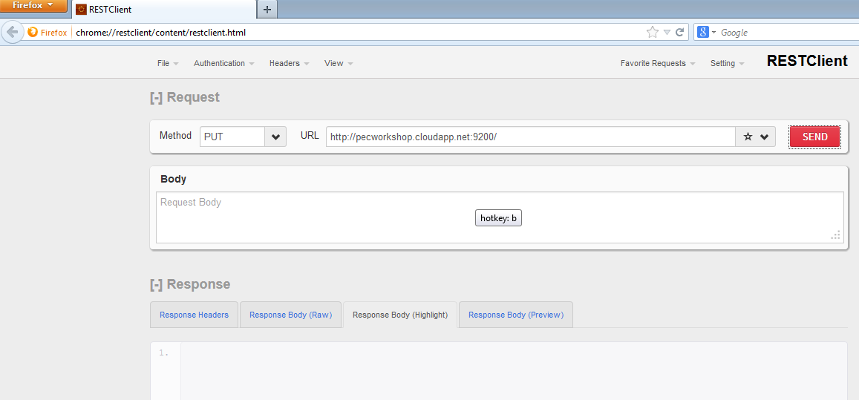
Note: If you're using Chrome browser use POSTMan REST Client exension. If it's not installed install the same from (https://chrome.google.com/webstore/detail/postman-rest-client/fdmmgilgnpjigdojojpjoooidkmcomcm)
All the steps below will assume using RESTClient tool in Firefox browser. Follow the same steps in Chrome too using POSTMan Client tool
REST Client Usage:
- The RESTClient is used to send the HTTP requests to the ElasticSearch
- Choose the appropriate HTTP method from the dropdown
- The base URL should point to http://pecworkshop.cloudapp.net:9200/
- Enter the Request details in the Body text area

Steps to create Index:
Note: Index are something similar to database in RDBMS
1. Choose a unique name
2. From the RESTClient choose method as 'PUT' and URL as http://pecworkshop.cloudapp.net:9200/<Your Index Name> e.g., http://pecworkshop.cloudapp.net:9200/myindex
3. You should get a response as below
{
"ok": true,
"acknowledged": true
}
4. In the subsequent steps you should always use the index that you've created e.g.,http://pecworkshop.cloudapp.net:9200/myindex
Steps to create a type
Note: Type is similar to a table in a database
1. Choose a name for creating a type
2. From the RESTClient choose method as 'PUT' and URL as http://pecworkshop.cloudapp.net:9200/<Your Index Name>/product e.g., http://pecworkshop.cloudapp.net:9200/myindex/mytype
3. You should get a response as below
{
"ok": true,
"acknowledged": true
}

Create mapping for the documents:
URL: http://pecworkshop.cloudapp.net:9200/<your index>/product/_mapping
HTTP Method: PUT
Body: Content from "mapping.txt" from path \pec-xml-workshop\Hands-on\Elasticsearch Data\products
Result:
{
"ok": true,
"acknowledged": true
}
Populate the documents :
URL: http://pecworkshop.cloudapp.net:9200/<your index>/product/1
HTTP Method: PUT
Body: Copy the first line from "documents.txt" from path \pec-xml-workshop\Hands-on\Elasticsearch Data\products
Result:
{"_index":"testprods","_type":"product","_id":"1","exists":false}

Repeat the above steps for the all the 6 lines in the "documents.txt" by changing the counter in the URL like http://pecworkshop.cloudapp.net:9200/<your index>/product/2 etc.,

Run simple search queries:
URL: http://pecworkshop.cloudapp.net:9200/<your index>/_search
HTTP Method: POST
Body: Copy the below and paste in the body text area
{
"query": {
"filtered": {
"query": {
"match": {"_all": "network routing"}},
"filter": {
"term": {"department_id": 1}}
}}}
Faceted Search on Price:
URL: http://pecworkshop.cloudapp.net:9200/<your index>/_search
HTTP Method: POST
Body: Copy the below and paste in the body text area
{
"query": {
"match": {"_all": "network routing"}},
"facets":{
"department_id": {"terms": {"field": "department_id"}},
"department_name": {"terms": {"field": "department_name"}},
"price": {"histogram": {"field": "price", "interval": 5000}}} }

Faceted Search on Price - Filtered at two level:
URL: http://pecworkshop.cloudapp.net:9200/<your index>/_search
HTTP Method: POST
Body: Copy the below and paste in the body text area
{
"query": {
"filtered": {
"query": {
"match": {"_all": "network routing"}},
"filter": {
"and": [
{"range": {"price": {"gte": 0, "lte": 5000}}}
]} }},
"facets":{
"department_id": {"terms": {"field": "department_id"}},
"department_name": {"terms": {"field": "department_name"}},
"price": {"histogram": {"field": "price", "interval": 5000}}} }

{
"query": {
"filtered": {
"query": {
"match": {"_all": "network routing"}},
"filter": {
"and": [
{"range": {"price": {"gte": 0, "lte": 5000}}}
]} }},
"facets":{
"department_id": {"terms": {"field": "department_id"}},
"department_name": {"terms": {"field": "department_name"}},
"price": {"histogram": {"field": "price", "interval": 5000}}} }

